Technical Product Specification Paper



**Class:** EE 585

**Team Name:** TeamLotus

**Team Members:** Sailesh Rajanala, Priyanka Limbu, Subash Acharya, Shiva Karki, Waryam Mazhar

**Project Name:** Industry Partner Database

**Date**: 10/11/2020

# Product Description

The Industry Partner Database is designed to provide an easily accessible and secure forum for professors, college deans, industry partners, and students to view, interact with, and share information. Currently there is no centralized forum for viewing the most up-to-date information but this database will serve to bring the existing scattered information to one place. As we would be providing the latest information it will help everyone make informed decisions and seek out opportunities for their personal and professional development which otherwise would have been left unfulfilled.

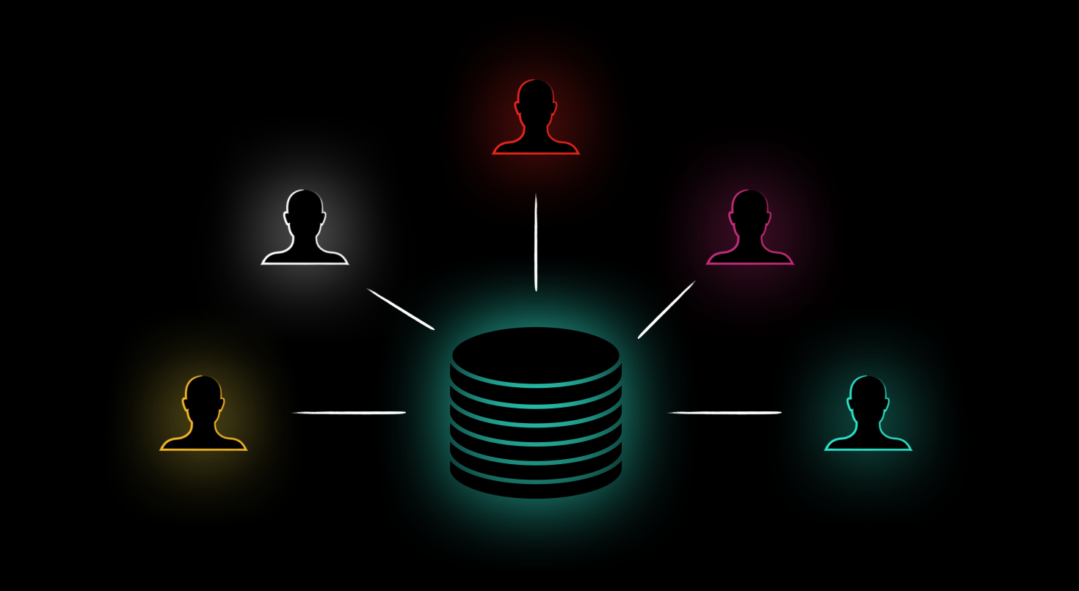

Diagram: Unified Database

# Standards and Regulations

Current Known Standards to be followed:

FERPA standards are to be followed along with basic IT Database standards when it comes to updates. We also need to keep in mind the legal and ethical part and keep them aligned to database standards as well as it is highly important as the database evolves. These include handling duplication of accounts, making sure there is no false information being uploaded, avoiding scam artists and spam from external sources.

In addition to already existing standards like FERPA we will be making some standards on our own in accordance to the requirements of the Project. A majority of these standards will involve compliance of data, level of accessibility, and data update responsibility.

1. **Compliance of data:** This will involve making sure that sensitive information is managed in such a way that it achieves the purpose of the database and information sharing however is done in accordance to legal and ethical regulations.
2. **Level of accessibility:** This will make sure that appropriate permissions are set-up between different levels of hierarchy to make sure that each person is viewing information he/she is allowed to view. This accessibility of data will be determined by the project organizer and should meet project requirements.
3. **Data update responsibility:** Although this is something of concern for the future when the database is set-up and running we still need to make sure that data is handled and updated in a way as to people know how to update relevant information and adhere to data up-date standards making sure that the data is accurate and up-to-date. In order for this to be achievable database training will be involved which will let users know how to update relevant information in a precise and timely manner.

# Software Details

1. Product Specifications:

While working on the project requirements phase and gathering information about various technologies to use, we contacted the Media Resources Center on campus to investigate about the technologies that are being currently used by the Website management team of the institution. Therefore, we were provided with a list of technologies including their specifications for various parts of the university’s website. Below is an illustration that depicts the basic workflow and the relation between a web server, a database, and a webpage.

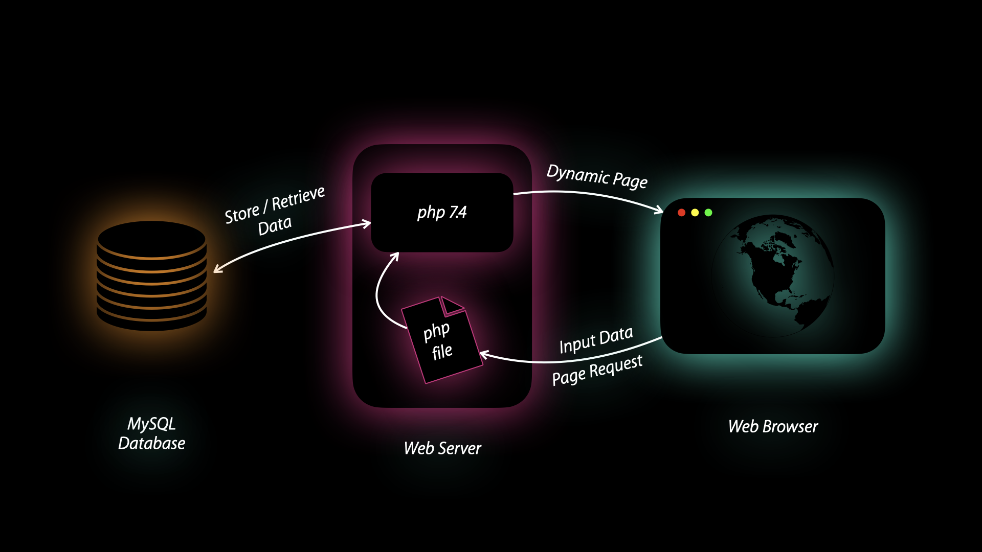

Diagram: Workflow

Workflow Description :

**Data Input:**

Firstly, the user uses the webform listed in the webpage to input their information. The information provided by the user is sent over to the php file where it is processed. The processed information is then stored in the database.

**Data Retrieval :**

When the user visits the webpage they will be provided with the latest information. It will also have the option to search for contact information stored in the database based on the provided filter keyword.

Technologies :

**Front End:**

The front end of the webpage will be developed using the following technologies.

***HTML 5 (Hyper Text Markup Language)***

HTML will serve as the backbone of the page. It will define how the webpage will be structured and what fields it will have.

|  |  |
| --- | --- |
| Advantages of using HTML 5 | Disadvantages of using HTML 5 |
| The coding with HTML5 is clear and consistent. | It requires a modern browser to access it. |
| There are more page layout elements available for our content | Multiple device responsiveness could be a headache. |

***CSS 3 (Cascading Style Sheets)***

CSS is used to determine the look of the webpage in general. It will define color, font type, background, layout and overall look of the page. It is also responsible for making the website responsive and work across all types of devices. (Smart Phone to Desktop)

|  |  |
| --- | --- |
| Advantages of using CSS 3 | Disadvantages of using CSS 3 |
| It improves web page loading speed. | It has cross browser issues, it means CSS works differently on different browsers. |
| It lets you define changes in the position of web elements present on a page | It Lacks security, because it is an open text-based system, CSS doesn’t have the built-in security that will protect it from being overridden. |

***Javascript***

Javascript makes the webpage dynamic. It is used to add functions to various elements in the webpage. For instance, performing an action when the users clicks a button, detecting if a user is offline etc. Javascript brings life to a webpage.

|  |  |
| --- | --- |
| Advantages of using Javascript | Disadvantages of using Javascript |
| Server Load - JavaScript is client-side, so it reduces the demand on servers overall, and simple applications may not need a server at all. | Client-Side Security - Since JavaScript code is executed on the client-side, bugs and oversights can sometimes be exploited for malicious purposes. Because of this, some people choose to disable JavaScript entirely. |
| Interoperability - Unlike PHP or other scripting languages, JavaScript can be inserted into any web page. JavaScript can be used in many different kinds of applications because of support in other languages like Pearl and PHP. | Browser Support - While server-side scripts always produce the same output, different browsers sometimes interpret JavaScript code differently. |

**Back End:**

***php 7.4***

php will be used as the primary programming language for the backend. The information provided by the user is processed in this section. If the user is providing input information, it will be sent over to the database for storage. If the user requests information, php will retrieve information from the database and send it to the browser.

|  |  |
| --- | --- |
| Advantages of using php 7.4 | Disadvantages of using php 7.4 |
| It is an Open source software, It is developed and maintained by a large group of developers. This will help in creating a support community and abundant extension libraries. | Security, Since it is open sourced, all people can see the source code. If there are bugs in the source code, it can be used by people to explore the weakness of it. |
| Speed, It is relatively fast, since it uses not much system resources. | Not suitable for large applications, It will be difficult to use it for programming huge applications. Since the programming language is not highly modular, huge applications created out of the programming language will be difficult to maintain. |

**Database:**

***MySQL***

MySQL will be used to manage the database. It is a relational database management system (DBMS). It will consist of various tables to store different kinds of information i.e. strings, numbers, characters etc. We will use MySQL Queries to retrieve various types of information from the database.

|  |  |
| --- | --- |
| Advantages of using MySQL | Disadvantages of using MySQL |
| It is open source, Using open source software costs less money and is safe because everyone can access its source code , any problem can be fixed quickly. | It works fine in most small or medium applications, but when data size grows, the performance degrades. |
| It is easy to interact with, and the features are rich and we don't need too much knowledge to use at the same time. | It is not easy to develop and maintain stored procedures. Developing and maintaining stored procedures are often required for a specialized skill set that not all application developers possess. |

Decision Reasoning:

* + **HTML 5, CSS 3 and Javascript for Front End:** We decided to use HTML 5, CSS 3 and Javascript because they are industry standard languages or technologies that are used to create a webpage. More importantly, our university also uses these technologies for maintaining its webpages. This is the main reason why we are not considering other alternatives like Haml, Adobe Postscript, and Typescript. Using these technologies will promote the Sustainability, Adaptability and Expandability aspects of our project. Since PHP is dynamically typed, it means you’re able to come up with a variety of solutions and workarounds for one problem

* + **php 7.4 for Back End:**. Since PHP is dynamically typed, it means we are able to come up with a variety of solutions and workarounds for one problem. It’s more forgiving of errors, which means that we are able to compile and run a program until you reach a problematic part. There is an abundance of resources dedicated to the language as a result of the large community and tool support. We can Collect form data, generate dynamic page content, Send and receive cookies, write command line scripting, andwrite server-side scripting using PHP.

* + **MySQL for Database:** MySQL is scalable and can handle a huge amount of data. It can support multiple storage engines whereas other systems like SQL server support only one storage engine.It works on many platforms, so it is easy to deploy and use.

Work Cited

[1]<https://learntocodewith.me/posts/backend-development/>

*What Is MySQL?: Key Concepts & Reasons Why You Should Use MySQL*. 23 Apr. 2020, www.educba.com/what-is-mysql/.